给你一个正整数 n ，生成一个包含 1 到 n² 所有元素，且元素按顺时针顺序螺旋排列的 n x n 正方形矩阵 matrix 。

示例 1：
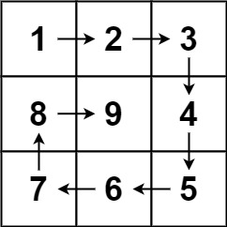
输入：n = 3
输出：[[1,2,3],[8,9,4],[7,6,5]]
示例 2：
输入：n = 1
输出：[[1]]

提示：
- 1 <= n <= 20

//2026.8.30
class Solution {
public:
vector<vector<int>> generateMatrix(int n) {
vector<vector<int>> res(n, vector<int>(n, 0));
int startX = 0;
int startY = 0;
int offset = 1;
int count = 1;
int loop = n /2;
while ( loop-- ) {
int i = startX;
int j = startY;
for (j; j < n - offset; j++) {
res[i][j] = count++;
}
for (i; i < n - offset; i++) {
res[i][j] = count++;
}
for (j; j > startY; j--) {
res[i][j] = count++;
}
for (i; i > startX; i--) {
res[i][j] = count++;
}
startX++;
startY++;
offset++;
}
if ( n % 2 == 1) {
res [n / 2][n / 2] = n * n;
}
return res;
}
};

